train hate offensive none

7291 37070 51065 95426

7.6% 38.8% 53.5%

test 2540 10687 16947 30174

8.4% 35.4% 56.2%

1 run......

Downloading: 100%

466/466 [00:00<00:00, 17.3kB/s]

Downloading: 100%

542M/542M [00:17<00:00, 31.9MB/s]

training 1 epoch...

2613.6036801338196 seconds used......

1 training finished! average train loss: 0.399780221343156

evaluating...

Confusion matrix, without normalization

[[ 739 733 1068]

[ 352 9390 945]

[ 317 593 16037]]

Normalized confusion matrix

[[0.29094488 0.28858268 0.42047244]

[0.03293721 0.8786376 0.08842519]

[0.01870538 0.03499144 0.94630318]]

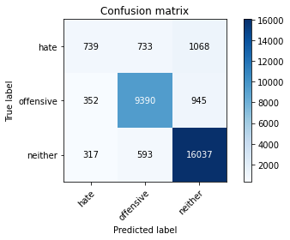

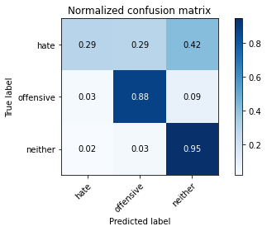

precision recall f1-score support

hate 0.52 0.29 0.37 2540

offensive 0.88 0.88 0.88 10687

neither 0.89 0.95 0.92 16947

accuracy 0.87 30174

macro avg 0.76 0.71 0.72 30174

weighted avg 0.85 0.87 0.86 30174

average eval_loss: 0.3755430964774016, accuracy: 0.8671704116126466

training 2 epoch...

2614.0166902542114 seconds used......

2 training finished! average train loss: 0.31303996980355775

evaluating...

Confusion matrix, without normalization

[[ 583 827 1130]

[ 190 9438 1059]

[ 199 448 16300]]

Normalized confusion matrix

[[0.22952756 0.32559055 0.44488189]

[0.01777861 0.88312904 0.09909236]

[0.01174249 0.02643536 0.96182215]]

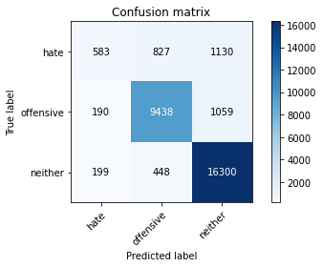

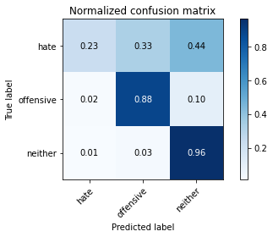

precision recall f1-score support

hate 0.60 0.23 0.33 2540

offensive 0.88 0.88 0.88 10687

neither 0.88 0.96 0.92 16947

accuracy 0.87 30174

macro avg 0.79 0.69 0.71 30174

weighted avg 0.86 0.87 0.86 30174

average eval_loss: 0.3783302452850956, accuracy: 0.8723072844170477

training 3 epoch...

2615.0541620254517 seconds used......

3 training finished! average train loss: 0.24314775141869413

evaluating...

Confusion matrix, without normalization

[[ 816 838 886]

[ 329 9564 794]

[ 514 764 15669]]

Normalized confusion matrix

[[0.32125984 0.32992126 0.3488189 ]

[0.03078507 0.89491906 0.07429587]

[0.03032985 0.04508173 0.92458842]]

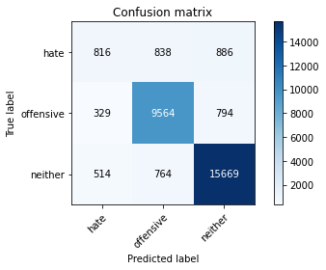

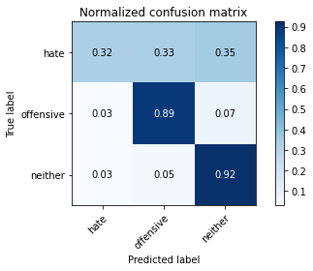

precision recall f1-score support

hate 0.49 0.32 0.39 2540

offensive 0.86 0.89 0.88 10687

neither 0.90 0.92 0.91 16947

accuracy 0.86 30174

macro avg 0.75 0.71 0.73 30174

weighted avg 0.85 0.86 0.86 30174

average eval_loss: 0.4369606939079629, accuracy: 0.8632929011731955

training 4 epoch...

2615.8673856258392 seconds used......

4 training finished! average train loss: 0.17372358261693654

evaluating...

Confusion matrix, without normalization

[[ 613 914 1013]

[ 257 9527 903]

[ 352 758 15837]]

Normalized confusion matrix

[[0.24133858 0.35984252 0.3988189 ]

[0.02404791 0.89145691 0.08449518]

[0.02077064 0.04472768 0.93450168]]

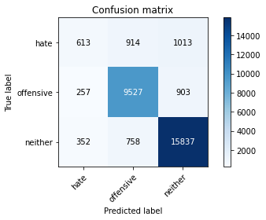

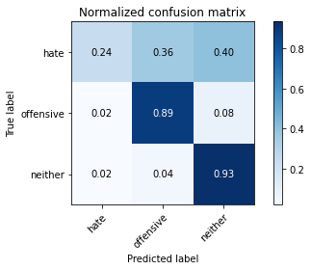

precision recall f1-score support

hate 0.50 0.24 0.33 2540

offensive 0.85 0.89 0.87 10687

neither 0.89 0.93 0.91 16947

accuracy 0.86 30174

macro avg 0.75 0.69 0.70 30174

weighted avg 0.84 0.86 0.85 30174

average eval_loss: 0.5586973205134717, accuracy: 0.860906740902764

training 5 epoch...

2618.410326242447 seconds used......

5 training finished! average train loss: 0.1231237434144292

evaluating...

Confusion matrix, without normalization

[[ 858 730 952]

[ 501 9286 900]

[ 498 677 15772]]

Normalized confusion matrix

[[0.33779528 0.28740157 0.37480315]

[0.04687939 0.86890615 0.08421447]

[0.02938573 0.03994807 0.93066619]]

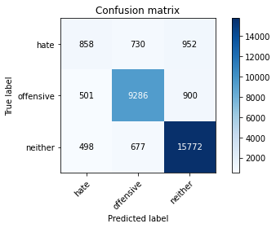

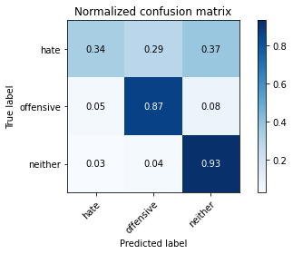

precision recall f1-score support

hate 0.46 0.34 0.39 2540

offensive 0.87 0.87 0.87 10687

neither 0.89 0.93 0.91 16947

accuracy 0.86 30174

macro avg 0.74 0.71 0.72 30174

weighted avg 0.85 0.86 0.85 30174

average eval_loss: 0.6387760042024047, accuracy: 0.8588851328958707

training 6 epoch...

2617.7979390621185 seconds used......

6 training finished! average train loss: 0.09003591582345008

evaluating...

Confusion matrix, without normalization

[[ 944 726 870]

[ 533 9284 870]

[ 737 753 15457]]

Normalized confusion matrix

[[0.37165354 0.28582677 0.34251969]

[0.04987368 0.868719 0.08140732]

[0.04348852 0.04443264 0.91207883]]

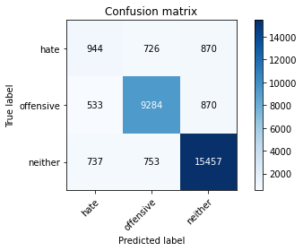

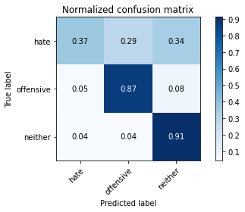

precision recall f1-score support

hate 0.43 0.37 0.40 2540

offensive 0.86 0.87 0.87 10687

neither 0.90 0.91 0.91 16947

accuracy 0.85 30174

macro avg 0.73 0.72 0.72 30174

weighted avg 0.85 0.85 0.85 30174

average eval_loss: 0.659939973415144, accuracy: 0.8512295353615695

training 7 epoch...